A [**left-skewed distribution**](https://www.statisticshowto.com/probability-and-statistics/skewed-distribution/#SkewLeft) has a long left tail. Left-skewed distributions are also called negatively-skewed distributions. That’s because there is a [long tail](https://www.statisticshowto.com/long-tail-distribution/) in the negative direction on the number line. The mean is also to the left of the [peak](https://www.statisticshowto.com/peak-of-a-distribution/).

A [**right-skewed distribution**](https://www.statisticshowto.com/probability-and-statistics/skewed-distribution/#SkewRight) has a long right tail. Right-skewed distributions are also called positive-skew distributions. That’s because there is a long tail in the positive direction on the number line. The [mean](https://www.statisticshowto.com/probability-and-statistics/statistics-definitions/mean-median-mode/#mean)is also to the right of the peak.

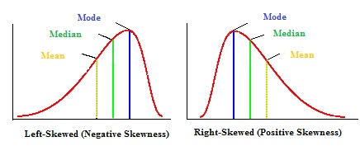

Mean and Median in Skewed Distributions

In a normal distribution, the [mean](https://www.statisticshowto.com/probability-and-statistics/statistics-definitions/mean-median-mode/#mean)and the [median](https://www.statisticshowto.com/probability-and-statistics/statistics-definitions/mean-median-mode/#median)are the same number while the mean and median in a skewed distribution become *different* numbers:

A left-skewed, negative distribution will have the mean to the **left** of the median.

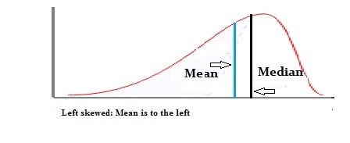

A right-skewed distribution will have the mean to the **right**of the median

